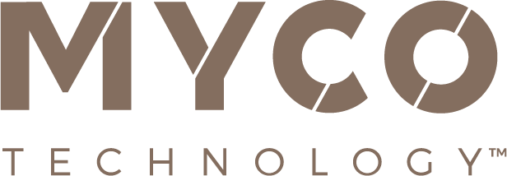

16 October 2023
PRESS RELEASE
MycoTechnology Launches Fermentation as a Service, Unlocking Scalable Biomanufacturing Amidst Industry Capacity Crunch
Meet with MycoTechnology at SupplySide West: Booth #3519
Confronting the global bottleneck in fermentation capacity, MycoTechnology, Inc., a frontrunner in mushroom mycelial fermentation, announces the launch of its U.S.-based Fermentation as a Service (FaaS) platform. This groundbreaking initiative is a valuable opportunity for start-ups and innovative enterprises struggling to secure fermentation capacity during a critical industry shortage.
FaaS promises to provide companies with unparalleled access to essential tools and expertise, enabling them to efficiently scale up their fermentation operations from volumes as low as 300 litres to an astounding 90,000 litres. FaaS empowers companies to overcome challenges related to product quality, yield, and cost management as they make the leap to commercial production.
Ranjan Patnaik, Chief Technology Officer at MycoTechnology, elaborated, “Fermentation is a critical process that underpins the production of a wide array of bioproducts. However, scaling up can be fraught with difficulties, and fierce competition for fermentation capacity is resulting in bottlenecks, delays and escalating costs. These factors are creating major barriers to entry into the sector. But by opening up our facility to others, we aim to foster breakthroughs and accelerate the pace of innovation.”
The FaaS platform accommodates a diverse range of bioproducts, including proteins, enzymes, and probiotics. It operates under rigorous regulatory standards, adhering to FDA 21 CFR Part 117 guidelines and boasting a GFSI audit certification from BRCGS, ensuring a robust and reliable facility for fermentation services.
In an era where the U.S. biomanufacturing sector is actively working to bridge the fermentation capacity gap, supported by initiatives like the BioMADE program, MycoTechnology's FaaS emerges as a pivotal player. This initiative not only aligns with the growing efforts to enhance the U.S. bioindustrial landscape, but also paves the way for other companies facing capacity constraints to envision a future filled with potential and innovation.
MycoTechnology will be exhibiting at SupplySide West at Mandalay Bay, Las Vegas, on 25-26 October 2023 at Booth #3519, with experts on hand to answer questions about the FaaS platform and discuss all aspects of the fermentation process. The spotlight will also be cast on MycoTechnology’s own fermented protein solutions, showcasing how the company is revolutionizing plant-based dairy alternatives through advanced nutrition, taste, and texture.
For further details, reach out to:
Richard Clarke, Ingredient Communications
Email: richard@ingredientcommunications.com
About MycoTechnology, Inc.
Established in 2013 and based in Aurora, Colorado, MycoTechnology creates products from mushroom mycelia that solve the biggest challenges in the food industry. The world’s leading explorer of mycelia, MycoTechnology is dedicated to increasing the availability of healthy, sustainable, clean label and high-quality food options through natural mushroom fermentation. Its product portfolio includes ClearIQ™ flavor, a line of transformative mushroom-derived flavor modulation tools that decrease the perception of bitter and off-notes, enable the formulation of products with higher nutrient density, and reduce salt and sugar across a broad spectrum of applications. MycoTechnology also offers FermentIQ™ protein, a line of plant protein products produced via a proprietary fermentation process that harnesses the power of mushroom mycelia to make plant proteins that are more functional, easier to digest, and more delicious. MycoTechnology is a team of near 100 employee-shareholders and continues to recruit additional colleagues to aid expansion and growth.

